Mean > Median > Mode for all the columns

Mean>Median<Mode for salary column

**Skewness for all the columns:**

**SSC_P:**

* Skew value is positive for ***SSC_P (1.91858),*** and the ***mean, median*** and ***mode*** relationship for the column is as shown below

**Mean>Median>Mode**

**HSC_P:**

* Skew value is positive for ***HSC_P (1.839298),*** and the ***mean, median*** and ***mode*** relationship for the column is as shown below

**Mean>Median>Mode**

**Degree_p:**

* Skew value is positive for ***degree_p*** (**1.879479**),and the ***mean, median*** and ***mode*** relationship for the column is as shown below

**Mean>Median>Mode**

**Etest_p:**

* Skew value is positive for ***etest_p*** (**1.781288**), and the ***mean, median*** and ***mode*** relationship for the column is as shown below

**Mean>Median>Mode**

**Mba_p:**

* Skew value is positive for ***mba_p (2.064549),*** and the ***mean, median*** and ***mode*** relationship for the column is as shown below

**Mean>Median>Mode**

**Salary:**

* Skew value is positive for ***salary*** (**2.042122**), and the ***mean, median*** and ***mode*** relationship for the column is as shown below

**Mean>Median<Mode**

***If the skew value is positive (right skew), then the relationship between the mean, median, and mode will be as follows,***

**Mean>Median>Mode**

***Here, for the salary column, the Mean is greater than the Median, but the Median is less than the Mode.***

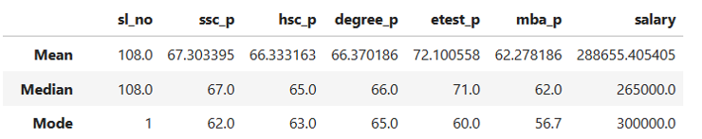

**Kurtosis for all the columns:**

**Kurtosis type based on the value:**

**<3 -Platykurtic**

**>3- Leptokurtic**

**=3-Mesokurtic**

**Ssc_p:**

* Kurtosis value of ***ssc_p (4.831444)*** which is >3, so it is Leptokurtic type

**Hsc_p**

* Kurtosis value of ***hsc_p (4.412629)*** which is >3, so it is Leptokurtic type

**degree_p**

* Kurtosis value of ***degree_p (4.874544)*** which is >3, so it is Leptokurtic type

**etest_p**

* Kurtosis value of ***etest_p (4.41463)*** which is >3, so it is Leptokurtic type

**mba_p**

* Kurtosis value of ***mba_p (5.549355)*** which is >3, so it is Leptokurtic type

**salary**

* Kurtosis value of ***salary (5.205123),*** *which* is >3, so it is a Leptokurtic type

**Overall, the kurtosis values of all the columns are greater than 3, so they are of the leptokurtic type**